|  |
| --- |
| BCIS301-AMIC700 |
| Solutions for performance improvement of Ara’s IT Department |
| Assessment 2 |

|  |
| --- |
| Kieran Abelen, Allen Zhang, Jerry Wang  10-14-2019 |

Contents

Introduction 2

Structure 3

Methodology 4

Data Analysis 5

Discussion 6

Outcome 7

Conclusion 8

Test 9

# Introduction

# Methodology

# Data Analysis

## Data used

We agreed that we would use every excerpt since the analysis might not be apparent until the gaps are identified. The excerpts need context so long enough to understand was is going on, for example all the bullet points under a heading.

## Validation

All the excerpts have been validated by asking if this is a true gap. The gap does not have to be a negative or problem aspect of an excerpt but could be a positive aspect.  
We where trying to identify what is important about each technology implementation.  
If there was something negative or positive what was the culprit or underling theme.

## Gaps: Meta-Factor

All gaps need to simple and explain as issue from a current solutions or lack of and the final solution. Let’s say the current system is Microsoft and everyone is used to this familiar style, and obvious gap is trying to get used to a new system. The gap is familiarity with best solution being the most familiar.

# Discussion

# Outcome

# evaluation tool

The table below shows all the group gaps and solutions for each gap.

|  |  |
| --- | --- |
| **Gaps** | **Solutions** |
| Automation | 1. Use Altius. Altius helps companies speed authorization for expenditure AFE approval times, automate workflows, and gain deeper insight into capital spend—resulting in better decision-making. 2. For attendance records, schools can use dynamic QR codes. Each course will be provided with a new time-limited QR code. Students can check in by scanning the QR code. This reduces the amount of work and also reduces the probability of errors in registration. |
| Communication | 1. Use skype, skype can share screens, all work on ONE single platform 2. Use Coggle. An online collaborative mind map. People can add/change things and do not need to gather up at the same place. |
| Compatibility | 1. Task management tool (i.e. Monday Project management tool)   www.monday.com/‎   1. Microsoft OneDrive Cloud storage. Microsoft OneDrive storage has been adopted by most education institutions. |
| Familiarity | 1. Trello with Microsoft Power BI. Trello has been used as an alternative collaboration tool and it has proved to provide a more user-friendly experience in comparison to Microsoft Team and SharePoint. A suggestion is to sanction Trello as an official collaboration tool and upgrade it to the enterprise version. Trello can be easily integrated with Microsoft Power BI via Stitch to analyse the Trello data by Power BI. |
| Urgency | 1. CISCO costs a lot. Schools can recruit more students, and not only can they train teachers, so they can not only make money but also cultivate talents. And CISCO Academy should record every expense for recording and backup. 2. Ara should upgrade the backend equipment as much as possible, although this will lead to an increase in upfront costs, but the benefits will be higher. Good devices can run daemons more efficiently. Not only that, but schools can also have better… |
| Security | 1. Purchase the official version of Coggle to ensure security and usability. If the budget is tight, we can consider replacing the software. |
| Training | 1. Web Crawling technique (i.e. Apify)   https://apify.com/ |

Evaluation tool

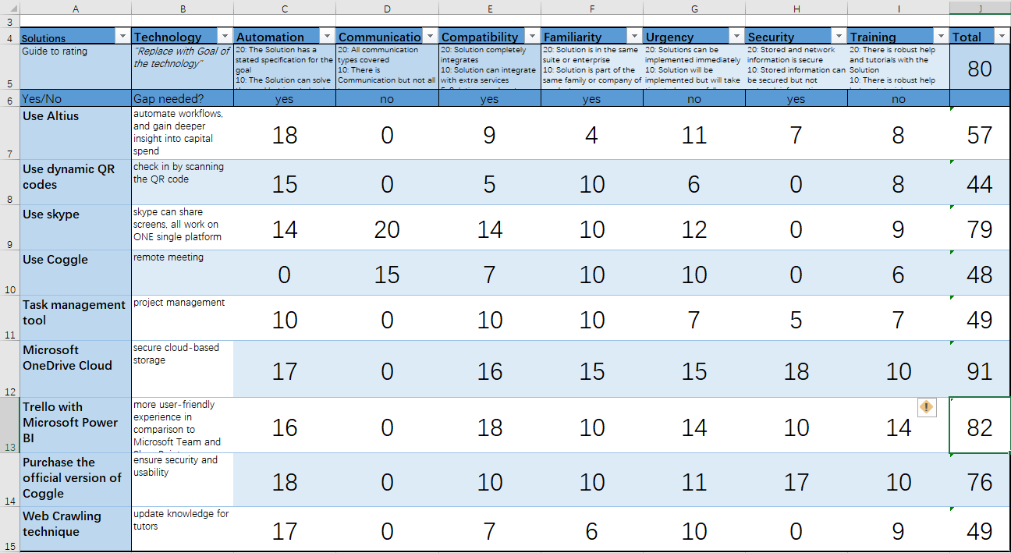

The selected technology projects from the pool of solutions for the next three years are by using evaluation tool are: Microsoft OneDrive Cloud, Skype, Trello with Microsoft Power BI.

# Conclusion

Our main goal is to provide the best solutions to improve the performance of the Department of Computing at Ara. Firstly, we completed our qualitative data of Ara’s IT Department based on the given transcripts and interview with other two teams through strategic analysis and grouped them up to seven main gaps, which are Communications, Compatibility, Familiarity, Urgency, Security, Training. Then we figured out the possible solutions based on the thoughts of ourselves, which will possibly improve the performance of Digital Innovation. In the main body, we explained the reasons how these solutions solve problems based on the four-element outcome. Secondly, we conducted evaluation by using the tool we built. Finally, three best solutions are selected from the pool of 9 technologies.

The planning hierarchy form are demonstrated below.

Goal

Solutions for performance improvement of Ara's IT department

Issues

Lack of software functionality

Manually operations

Limited storage

Communications

|  |
| --- |
|  |
|  |

automation Communication Compatibility Familiarity Security Training

solutions

official version of Coggle

Web Crawling technique

Trello with Microsoft Power BI

OneDrive Cloud

Task management tool

Coggle

skype

Dynamic QR code

Altius

Evaluation tool

Communication Compatibility Familiarity

Proposed

Trello with Microsoft Power BI

OneDrive Cloud

Skype

solutions